**EXPERIMENT-1**

**KALI LINUX BASIC COMMANDS**

**AIM:**

To execute the basic commands using kali linux.

**PROCEDURE:**

* Open the kali linux terminal.
* Enter the kali username and password.
* Enter the commands given.
* Commands will be executed and output will be shown.

**COMMANDS:**

* Date
* Cd Desktop
* Whoami
* Who
* ls –al
* echo
* mkdir
* ls
* rm
* uname
* uname –a
* users
* uptime
* less /etc/passwd
* moreetc/passwd
* vi
* free
* free –t
* sort
* sort –r
* history
* pwd

**OUTPUT:**

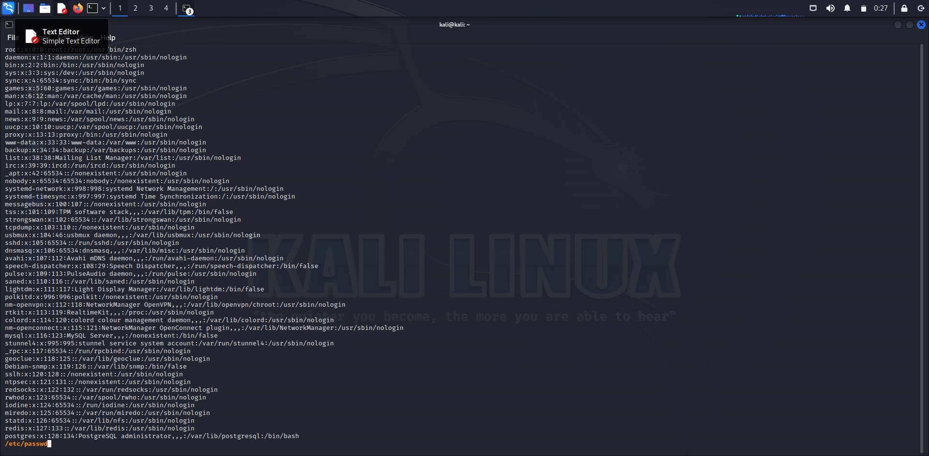

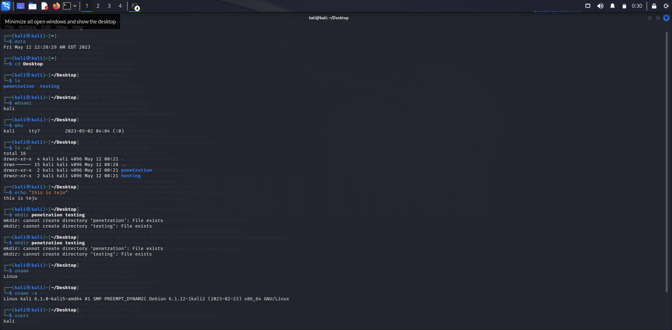

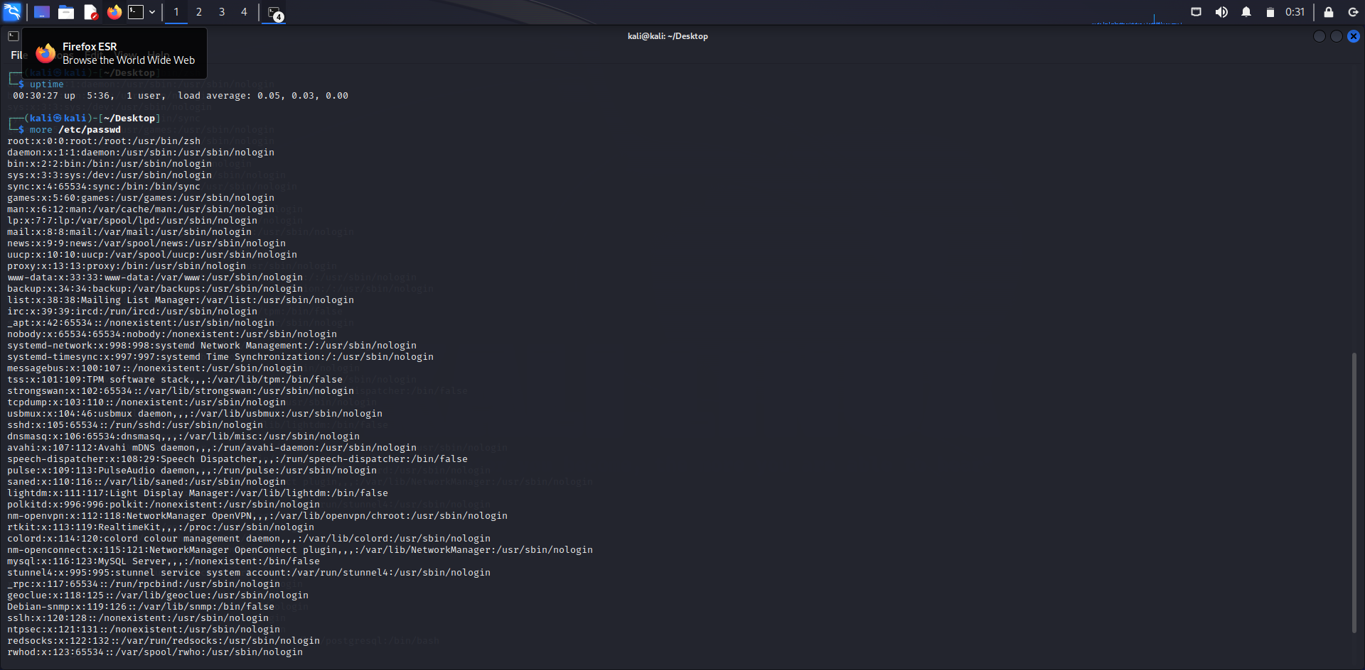

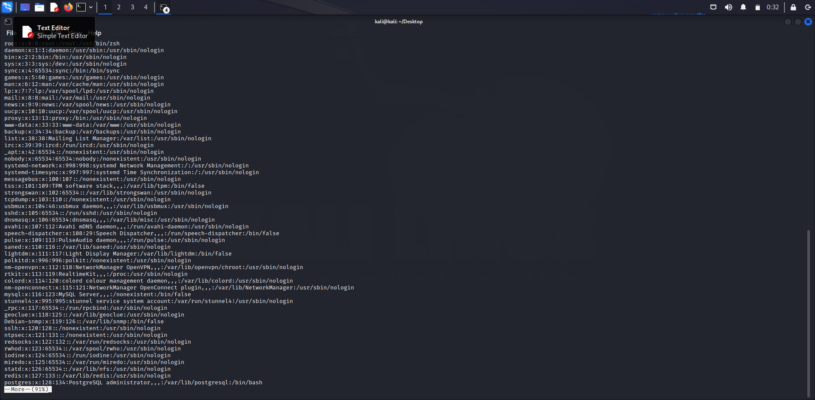

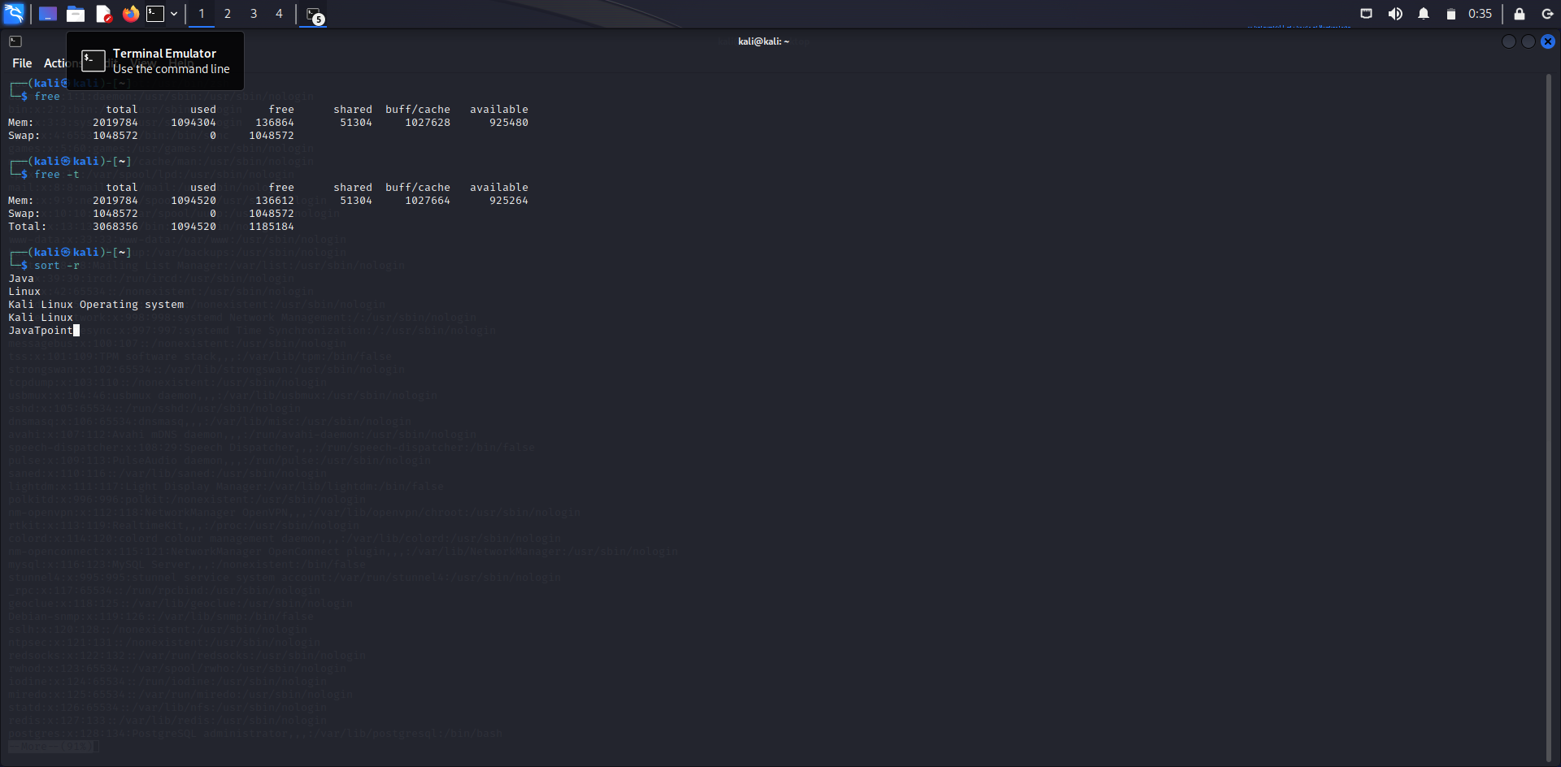

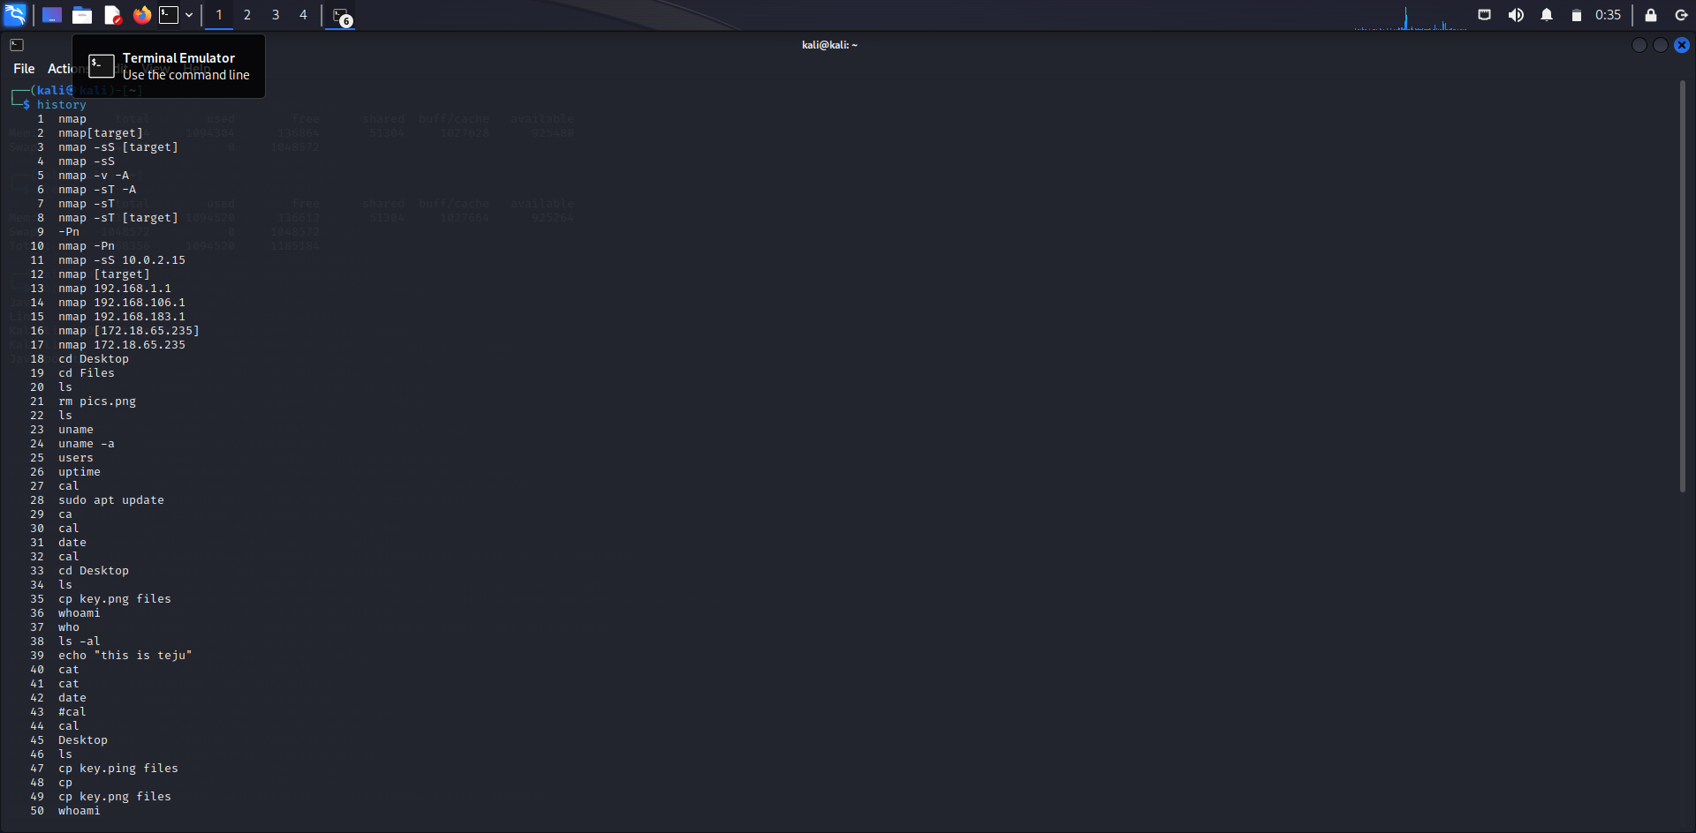

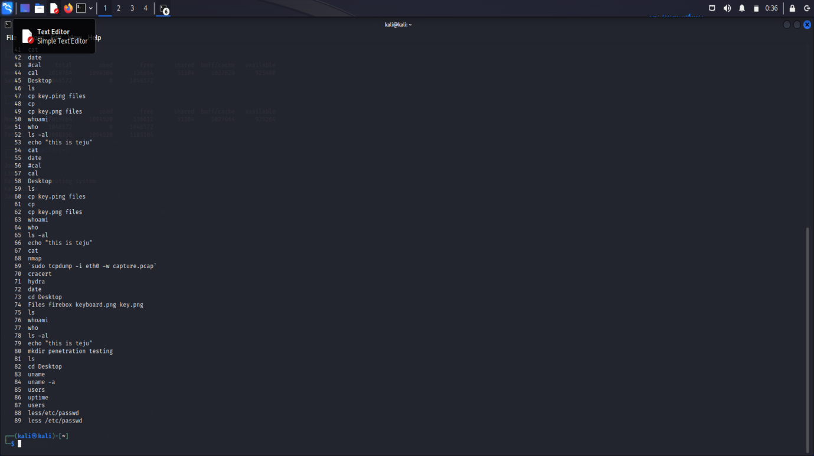

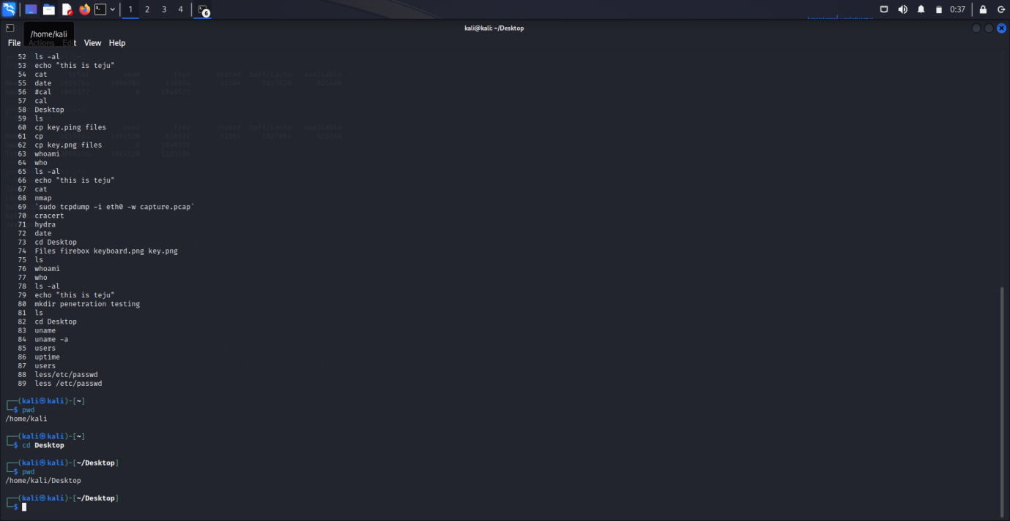

**RESULT:**

The basic commands using kali linux has been successfully executed.